***Nivea’s most controversial advertisement: “White Is Purity”***

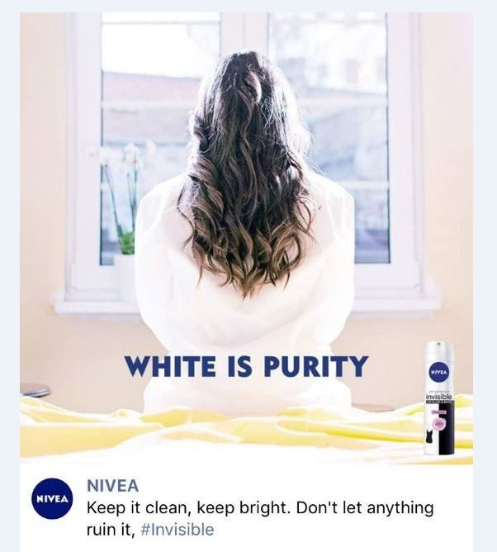

The NIVEA company has been judged since they posted this advertisement on their Facebook platform. This ad has been a topic of hundreds of newspapers and in the News in every world. After all of this big scandal, there has been thousands of people (specially women) who have felt judge for their skin color, by one of the biggest personal care brands globally. With this scandal, it has become more than clear that companies have to think more about what they are going to share in their advertisements, since they not only serve to sell products, but also to transmit certain messages, which can affect the self-esteem of their own customers.

This advertisement was posted in 2017, by Nivea Middle East in their Facebook platform. 2 hours after they posted it, they were immediate categorized as racist, with no more than 24hrs, NIVEA was in all the news, being tittle of newspapers and in all social media. This is the second time Nivea has been accused of promoting racist advertisements. After seeing all the scandal, negative comments and the huge impact that this advertisement had, they did not have more options that apologized with all the people that felt judged and delete it because it was taken as “misleading” after being posted for two days.

So far, it has been more than clear that brands advertisements are not just to sell products. This advertisement has impacted the lives of many of the buyers of this brand, which are more women than men. We know that most women in this world want to feel comfortable in their own body and not feel judged for their skin color. How do you think most of these women felt when they saw that the color black has been seen as "impure" by one of their favorite skin care brands? Because of this, brands should consider that their advertisements convey more than a simple product purchase and that they can affect other people's feelings. After this scandal, Nivea has experienced some rejection by people of color, after been categorized as one of the brands with the best products for lightening skin products. This announcement has caused the number of its buyers to decrease by a large amount, and get hate and negative criticism from many people around the world. This advertising has not only affected women's self-esteem, but can also affect their mental health, leading them to need therapy. After this, it is nothing more than a secret that women with low self-esteem have been more affected than others. We know that more women than men consume Nivea products, in order to feel more comfortable in their own body. After this announcement came to light, there has been a lot of criticism on social networks, especially by women. Since, as you can see, they feel offended that one of their favorite brands has called them impure and commented that the color black is seen as a "dirty" color, that only with Nivea products they can stay "clean."

Additionally, after this announcement was published, it took hours for it to be in all the news and trending on all social networks. They were the news and newspapers such as: The New York Times, BBC, CBS News, Los Angeles Times, CBC, The Washington Post, Teen Vouge and many more. Which did not help the famous brand because all these articles that these newspapers and news said were not very suitable for the great brand, which contributed to increasing the number of negative comments towards this brand.

To conclude, it has been more than clear all the impacts that a simple advertisement can have in the world. Just because we see it as a normal picture with a woman sitting on a window with the words “white” and “purity” in the same sentence, doesn’t mean that it’s just a phrase to sell a product. It can mean more than that for certain kind of people. It has been demonstrated that advertisements are not just to sell products, or to get the attention of a specific audience. Global companies should consider that their audience is not just from a specific ethnicity, they have customers from every part of the world, which comes with different cultures and skin colors. With all of this scandal, Nivea should be now thinking twice before publishing any advertisement, after being categorized as “racist company” because of two specific advertisements. Advertisements comes with more than the idea of selling or promoting products, it does affect the life or every person that sees it.